Abby Colehour, Long Tom Watershed Council, Eugene, OR, review 11.11.22

General comments:

* My background as a reviewer is as an applied ecologist and habitat restoration practitioner. I currently work for the Long Tom Watershed Council. I have spent the majority of my career in oak and prairie and deciduous forest habitats in Minnesota (2009-2013), and the Willamette Valley (2013-current). I have done a lot of hands-on forestry work and am currently a project manager coordinating larger scale habitat restoration projects. My experience with biochar comes from trying to make better use of slash as part of oak habitat restoration projects that involve tree and shrub thinning. I also regularly partner with Indigenous community members and Tribal staff in my work and have tried to offer feedback with respect to those relationships and what I have learned through them. I expect that the authors and other reviewers have more thoroughly reviewed the literature on scientific aspects of biochar, carbon sequestration, and the effects of biochar on soil than I have, so please keep that in mind as you read my questions and comments. My main contribution is in regards to how this methodology would play out in real world project applications, and in the context of community-based land tending working in solidarity with Indigenous people. I have tried to offer helpful suggestions that will make this methodology more widely applicable and accessible to practitioners like myself and my community partners
* It is exciting to see the evolution of biochar methodologies and the inclusion of biochar in the woods in those methodologies. This is an important step to keep biochar accessible, low-tech, and integrated into healthy forest management practices.
* Many of the methodologies outlined here, such as pile construction method, temperature of burning, and application rate varies too much by site and region to be able to standardize. If this methodology is to be accessible and applicable across multiple regions with adequate allowance for the natural changing variables in different situations, I recommend reframing the methods to outline the *principles* of good biochar production. You can standardize by measuring the *volume* of biochar produced, and reduce the need to control the *way* it is produced. See in-line comments for specific suggestions.
* Biochar is indeed a useful tool for turning waste biomass into a carbon sequestering substance in some situations. However, the practice of making biochar alone itself is not the answer or solution. It is one practice that needs to be rooted within a sustainable forest management system appropriate for the ecosystem in which it is occurring. This needs to be emphasized in the methodology. Imagining the trajectory of the carbon credit system and biochar…if we do not adequately position the practice of biochar production in the context of holistic forest management systems and whole ecosystem integrity, we risk land being converted from other uses or the wrong woody species being cut to make biochar, which would contribute to different ecological problems. Scaled up methodologies such as this should focus on principles that train practitioners to pay attention to their local landscape context and read the cues the land is providing to determine best practices, rather than looking to detailed prescriptions out of a report.

To demonstrate this point, take this example of an oversimplified approach to solving global crises. The “plant a tree” phenomenon is a common recommendation backed by numerous funding agencies to combat ecological degradation, desertification, and global warming. Yes, trees are valuable and important and should be planted in many contexts. But it is not appropriate to plant more trees in an overstocked drought-stressed conifer forest, nor in a prairie or an oak savanna whose diversity of flora and fauna depend on open canopy and understory conditions. These prairie and oak habitats support a massive diversity of life forms that will not persist in dense forested conditions, and the oversimplified “plant a tree” narrative has contributed to the degradation of these critical ecosystems. Similarly, it would not be appropriate to make biochar from a logging operation that involved the cutting of old-growth trees that were already storing massive amounts of carbon, nor mature trees along a riverbank that provide critical shaded waterways that provide critical salmon habitat. The gains of carbon sequestered through biochar made in those contexts would not outweigh the ecological losses. We are not going to solve global crises through oversimplified “cure-all” methods. We must learn our local landscapes, respect the complexity inherent within functional ecosystems, and integrate our social and ecological systems to uphold biodiversity and adapt to a changing world.

* I’d like to encourage the facilitators of this project to consider whether it is possible to anchor the project in alignment with [Tribal climate adaptation frameworks](https://tribalclimateguide.uoregon.edu/adaptation-plans) ([click here for weblink to a list of plans)](https://tribalclimateguide.uoregon.edu/adaptation-plans). Further, can this project get behind the return of land ownership, access, and management to Indigenous people? It is well documented that land managed by Indigenous communities support more biodiversity and ecosystem function, which will be critical for resilience and adaptation to climate change. If this can fit within the scope of the project, please let me know and I can pull together a list of some additional references on this topic that I am aware of.
* This methodology highlights “conservation burn piles” as one low-tech way to make biochar in the woods. There are a variety of other low-tech ways to make biochar in the woods, such as drag-and-feed. In that method, you cut and leave biomass scattered about to cure, then start a small central fire and drag material to it as the burn is occurring. The coals are prevented from turning to ash because additional material continues to be piled on top of it. Once all material has been burned, it can then be quenched with water, or shoveled into 55-gal metal drums (or similar portable vessel) and quenched by cutting off the supply of air. The point is, can you allow the in-stand surface application of biochar in forestlands methodology to be flexible enough to account for different methods like this? As I mentioned in the in-line comments, if you standardize and measure the output (volume of char produced), you can skip most of the details and instead emphasize the principles that yield good quantities of biochar while reducing smoke emissions and soil sterilization

Appendix: In-Stand Surface Application of Biochar in Forestlands

## Section 1: Introduction & Summary

### Overview

This document serves as a proposed appendix to the *Methodology for Biochar Utilization in Soil and Non-Soil Applications* currently under review by Verra. Specifically, this appendix outlines a well-supported exception to the limitations of *Section 4.* *Applicability Conditions*: *Eligible biochar end-use criteria*, to allow for in-stand surface level application of biochar as a unique soil amendment. We propose a project-design, from waste biomass sourcing through production and application, that justifies this change specifically for forest application.[1]

### Background & Reasoning

“For surface application, the biochar must be mixed with other substrates such as compost or manure.”[2] -Section 4. Methodology for Biochar Utilization in Soil and Non-Soil Applications, pg. 11.

We understand that the above language was intended to prevent loss of biochar to wind transport and erosion, likely in agriculture applications.[3] While relevant to application of biochar in an open field, this reasoning is not applicable to in-stand forest application for the following reasons:

1.1. *Protection from wind*: Unamended biochar will only be applied to the soil surface in forestland with adequate soil organic horizons. Biochar losses due to wind in such terrain are expected to be minimal. Furthermore, in accordance with best management practices to avoid wind loss, we will apply water to the biochar immediately after application.[4]

1.2. *Protection from water and erosion*: It is well documented that biochar improves soil water retention, thereby decreasing the risk of transport due to water runoff.[5] In a large rain event, biochar can absorb up to twice its weight in water, which significantly reduces the risk of catastrophic flooding. Water transport has also been found to be a more significant issue when applied to sloping terrain.[6] However, as long as the soil is intact and there are organic horizons to catch biochar, soil scientists with the Rocky Mountain Research Station have found that biochar remains on site even on slopes up to 35 degrees.[7] Our methods are specifically aimed at minimizing disturbance to soil and our project area does not include slopes greater than 35 degrees.

1.3. *Size of biochar particles:* Our project design will yield large biochar pieces averaging 1-3 inches in diameter that will not undergo grinding or any additional processing to reduce their size. This will significantly decrease the amount of biochar “dust” that is created, and therefore the risk of transport.[8] It has also been noted that biochar is often lost during transportation and mechanical spreading (for example in a lime spreader), two steps that our project design will entirely eliminate.[9]

Given our project boundaries and precautions, losses due to wind or water erosion should be de-minimis. From an ecological standpoint, place based-production and in-stand application will reduce soil disturbance and prevent the introduction of foreign materials to the forest ecosystem.[10] From an economic standpoint, this project model will significantly reduce costs for forest managers and is thus a much more realistic and scalable option.[11] Importantly, when biochar is applied as a unique soil amendment to forests it provides similar carbon, soil health, and other co-benefits compared to biochar amended with additional substrates, as long as the forest soil remains intact.[12] Therefore, our project will yield similar carbon sequestration and other benefits and can be calculated with the same metrics used in the *Methodology for Biochar Utilization in Soil and Non-Soil Applications.* As highlighted by local biochar expert, Kelpie Wilson, the best use of biochar would be to leave it in forest soils.[13]

## Section 2: Place-Based Production Methods

Place-based biochar involves both the production and application of biochar from feedstock originating on site. This sector uses leftover biomass residuals from a range of landscape management practices including logging, thinning, and other forestry activities. Place-based methods often utilize technologies with lower capital and operating costs, yet require a larger workforce to implement at scale. This provides a unique opportunity for green job creation, especially when implemented in conjunction with ongoing fuel reduction and vegetation management projects. By converting “waste” biomass into a valuable resource, place-based biochar has the potential to increase the economic viability and ecological benefits of current forest management practices.

### Conservation Burns

Conservation burns are a low-tech pyrolysis option that involve open pile burning without a kiln.[14] This is the simplest and most accessible way to produce biochar. When managed appropriately, conservation burns prevent incineration of the organic soil horizon associated with conventional slash pile burns.[15] In doing so, conservation burns curb the growth of invasive species, protect soil microbial life, and decrease carbon emissions.

Consistent with place-based production best practices the following methods will be employed:[16],[17],[18],[19]

2.1. *Description of piles*: Conservation burn piles will be constructed using feedstock of relatively consistent diameters, with a maximum diameter of approximately eight inches. These piles will be built in a cone shape, with the largest diameter material in the center of the piles, and the smaller material on the top and bottom. This will ensure that all materials will convert to char at approximately the same rate. Feedstock will be thoroughly dried using methods such as Kraft Paper coverings prior to burning. Piles will contain approximately 25% air space and be largely free of dirt and rock. Small piles no greater than 4-5 ft long will be used to ensure fast and even burning. Piles will be widely distributed across the project area to decrease labor costs and emissions from transporting feedstock, and to retain forest nutrients in place.

2.2. *Description of pyrolysis*: Unlike conventional burns, conservation piles will be lit from the top to create an oxygen limiting environment. As the flames move downward, they consume the oxygen that would otherwise reduce charcoal to ash. This leaves a low-oxygen environment on top where biomass is converted to charcoal. A temperature of 700-750° F will be maintained throughout to reduce emissions from pyrolysis. Pyrolysis will take approximately 20 minutes per pile, at which point the pile will be quenched with pressurized water. Quenching prevents ash formation and ensures maximum carbon sequestration. Quenching also protects underlying soils from incineration and reduces emissions by ensuring that most of the smoke is burned.

2.3. *Description of product*: Carbon conversion efficiency for conservation burns is estimated to be between 10-15%, however more field trials are needed to confirm this number.[20][21] Studies have found that the carbon content of biochar produced from conservation burns ranges from 50-80%.[22],[23],[24] Biochar produced at temperatures between 700-750° F using coniferous feedstock will produce a stable char with estimated pH levels in the range of 8-9.[25]

2.4 *Additional considerations:* Our first burns are scheduled for October, 2022. According to U.S Climate Data, Whatcom County averages 3.27 inches of rainfall in October. This is enough to help dampen biochar and reduce wind loss. Flooding is unlikely during October, which will reduce the risk of flood loss. Burns will only be executed on rainy days or within 2 days of at least .15 inches of rain.[26] No burn activities will occur if the weather predicts more than 14 mph. We will use the [CalTopo](https://training.caltopo.com/all_users/overlays/overlay-desc#wind) wind forecast mapping tool to choose an appropriate burn date for our project area.

### Surface Application Considerations

Surface application of biochar, when managed appropriately to prevent wind or water loss, provides important ecological benefits to the forest and economic advantages to the forest or project manager. First, surface application does not disturb the soil or introduce new substrates to the forest ecosystem. Maintaining soil structure and surface organic horizons is essential for maintaining soil health and storing carbon.[27] Second, surface application is a much more cost effective method of dispersion. Biochar is produced and applied on site which reduces transportation costs in both the sourcing and application stages. As noted by Rocky Mountain Research Station Economist Dr. Dan McCollum, “[Place-based biochar production] can change the economics of forest treatments, such as thinning and fuel reduction treatments, and forest restoration projects. The result might be that more projects are economically feasible, and more projects get done”.[28]

Consistent with place based production best practices the following application methods will be employed:[29],[30],[31],[32]

2.5. *Application rates:* Between 2-10 tons of biochar will be applied per acre, or about 16-18 cubic yards/acre.

2.6. *Application process:* For the pilot project, biochar will be manually applied and spread with rakes. This will minimize soil disturbance and costs. While still under development, researchers at The Missoula Technology and Development Center have partnered with the Rocky Mountain Research Station to design and test a high-capacity biochar spreader. This spreader can be mounted on a log forwarder and used on skid trails and log landings to distribute biochar. This type of technology will be critical to scaling place-based biochar production and application efforts for future projects.

## Section 3: Benefits of In-Stand Surface Application of Biochar

It is estimated that temperate-zone forests remove about 3.4 tonnes CO2 per hectare, of which 69%-92% is ultimately stored in soils.[33],[34] It is thus imperative that we maintain healthy and productive forests to mitigate climate change, as well as keep our air and water clean, reduce wildfire risk, and provide habitat for wildlife. Place based production and subsequent surface application of biochar can enhance forest health in the following ways: improve soil health, mitigate erosion, improve water quality, curb invasive species growth, and aid reforestation.[35] While burying biochar may be appropriate in some agricultural settings, it increases costs for forest managers and harms soil structure in forest settings. Surface application, however, requires fewer inputs and causes less disturbance to forest soils. Maintaining soil structure is key to keeping carbon in the ground.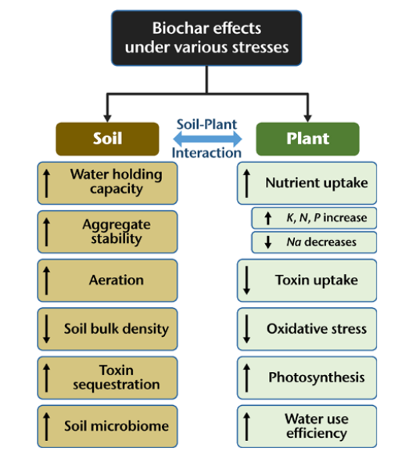

### Co-benefits

3.1. *Soil Health*: Biochar improves forest soil health in the following ways:

3.1.a.*Soil physical improvements:* Biochar can improve a range of soil physical properties, including soil porosity, pore-size distribution, bulk density, moisture holding capacity, infiltration, and hydraulic conductivity.[36],[37] Biochar is highly porous and can hold an estimated twice its weight in water for several days after a rain event.[38] This short-term buffering effect helps blunt the impacts of large rains that lead to flooding. The additional water storage capacity of soil amended with biochar also serves to enhance plant productivity.

3.1.b. *Soil chemical improvements*: Biochar has been shown to increase soil carbon stocks in forests by as much as 41%.[39] Although there is some evidence that biochar can deplete soil carbon stocks in the short term, biochar applied without additional organic materials appears to dampen this impact.[40] Soil carbon is the single best indicator of soil health. Biochar also increases nutrient availability, including soil phosphorous, potassium, and nitrogen, and decreases nutrient loss from leaching.[41],[42]

3.1.c. *Soil microbial improvements*: Biochar enhances microbial activity in forest soils, especially in the short term.[43],[44] Microbial biomass is the major agent for energy transfer and nutrient cycling in the soil system.[45] In their meta-analysis, Blanco-Conqui (2020) noted that ​​biochar can improve soil biological properties via the following mechanisms: provision of labile C and nutrients, nutrient retention by reducing losses (i.e., runoff, leaching, N2O emissions), provision of microhabitats within its porous structure, adsorption of microbes, increased water retention and availability, reduction in soil acidity, and adsorption of toxic elements and compounds.[46],[47],[48] Though increased microbial activity may increase soil greenhouse gas (GHG) emissions in the short term (1-6 years) due to respiration, biochar does not appear to impact soil GHG emissions over a longer time horizon.[49]

3.2. *Plant Growth*: Most studies related to biochar and plant growth have focused on agricultural applications. Preliminary research on the impacts of biochar on forest growth suggest a negligible to moderately positive impact.[50],[51] A recent meta-analysis found that when applied to forest soils, biochar amendments resulted in a 41% mean increase in woody biomass.[52] Another study in Finland found that pine trees amended with biochar showed a 25% increase in diameter and a 12% increase in height during the first three years.[53] Biochar is especially impactful to sapling growth and thus helpful for reforestation efforts after logging.[54] However, these impacts appear to dwindle as tree age increases.[55] Additionally, conservation burns avoid the scarring and subsequent growth of invasive species common after wildfires or slash pile burns.[56] Sites with biochar additions have shown improved native vegetation success and increases in pollinator plants and insects due to the enhanced soil health.[57]

### Maximizing Net Carbon Capture

In-stand surface application of biochar would reduce emissions in the sourcing, production, and application stages. Conservation piles are smaller and more distributed, requiring less movement of biomass. There are no additional scope one, two, or three emissions associated with conservation burns because no energy is required to operate, move, or build a kiln. Likewise, the biochar will not have to be transported or processed at an external location, which will also reduce emissions in the application stage. In addition to the carbon sequestration and resulting climate benefits of surface application, in-situ application will significantly reduce operation costs and emissions.

### Wildfire Mitigation and Recovery

In fire adapted forests, post-fire charcoal has long been an important source of soil organic carbon.[58] Studies have found that soil profiles from older forests show significant amounts of char, while soil profiles from younger forests that have undergone decades of fire suppression are severely lacking char.[59] Pre-colonial Indigenous communities in the American West performed frequent landscape burns that cleared forest understory and produced biochar.[60] This stewardship practice created exceptional wildlife habitat and a forest ecosystem that was more resistant to catastrophic fire. Revitalizing these practices through place-based biochar production may be our best tool to improve soil productivity and restore healthier fire regimes. “The best thing we could do with the char would be to leave it in the forest soils.”[61]

As more organizations look to prescribed burning as an essential fire risk reduction tool, there is growing potential for integration with biochar production. Converting forest slash from necessary wildfire thinning projects into biochar turns a costly and highly polluting waste disposal process (burning or chipping), into an economically viable and ecologically valuable solution. Leaving biochar on site to enrich forest soils should help forests become more resilient to the environmental stresses of climate change.[62] Though more research is needed, biochar may also aid in post fire soil recovery. One study found that biochar reduced soil erosion by 50% - 64% compared to unamended post-fire plots.[63]

Importantly, the climate mitigation potential of place-based biochar is not limited to the soil carbon sequestration achieved by adding biochar. “If biochar can be returned to forest soils at a large enough scale to improve soil and plant resiliency, it could be the difference between forests sequestering carbon or contributing carbon to the atmosphere through forest fires.”[64]

## Section 4: Parameters for Use in Future Projects

We propose the following considerations for use of this appendix in future projects:

4.1. Surface application of biochar as a unique soil amendment is only permissible in forestlands.

4.2. The following site-selection criteria should be considered to minimize biochar loss due to wind or water:

4.2.a. Biochar should not be added to slopes greater than 35 degrees. Biochar may only be added to areas containing adequate organic soil horizons that can “catch” biochar should any pieces be moved in water runoff.

4.2.b. Project application sites should include adequate windbreaks.

4.3. Additional precautions shall be undertaken to minimize biochar loss due to wind or water transport including, but not limited to:

4.3.a. Biochar shall be appropriately quenched to reduce ash formation.

4.3.b. Additional water should be added to thoroughly wet biochar immediately after application to the soil surface.

4.3.c. Biochar pieces should not be ground or otherwise processed to reduce their size. This will minimize the amount of biochar “dust” that is created.

4.4. All efforts to maintain soil structure shall be employed, including, but not limited to:

4.4.a. No tilling or digging.

4.4.b. The use of heavy machinery on intact forest soils should be minimized to avoid soil compaction. If machinery such as a high-capacity biochar spreader is needed, it can be mounted on a log forwarder and used on skid trails or log landings.

4.5. All other measurement, monitoring, and verification requirements applicable to forestry applications under the *Methodology for Biochar Utilization in Soil and Non-Soil Applications* and site specific work plans should be followed.

4.6. Care should be taken to time production and application with appropriate seasonal weather patterns.

4.6.a. For example, in the Pacific Northwest, biochar should be applied during the fall when precipitation increases but flood potential is still minimal. This will also ensure that the biomass has been thoroughly dried during the summer to create optimal biochar.

## Section 5: Summary

We propose an appendix to the current application requirements under the *Methodology for Biochar Utilization in Soil and Non-Soil Applications,* specifically to allow for in-forest surface application of biochar as a unique soil amendment. In contrast to the current methodology that limits unamended biochar to subsurface soil application, we propose a project design that reduces soil disturbance, decreases prohibitive economic barriers, and maintains the high standards of measurement, monitoring, and verification necessary to support the integrity of carbon markets consistent with the purposes of the methodology. Surface application of biochar in forests, when managed appropriately to reduce the risks of wind and water loss, solves the economic and ecological problems associated with digging or mixing biochar with additional compost or manure substrates.

## Section 6: Resources

Ameloot, N., Graber, E. R., Verheijen, F. G. A., & Neve, D. (2013). Interactions between biochar stability and soil organisms: review and research needs. *European Journal of Soil Science*, 64, 379– 390.

Amonette, J.E., J.G. Archuleta, M.R. Fuchs, K.M. Hills, G.G. Yorgey, G. Flora, J. Hunt, H.-S. Han, B.T. Jobson, T.R. Miles, D.S. Page-Dumroese, S. Thompson, K.M. Trippe, K. Wilson, R. Baltar, K. Carloni, C. Christoforou, D.P. Collins, J. Dooley, D. Drinkard, M. Garcia-Pérez, G. Glass, K. Hoffman-Krull, M. Kauffman, D.A. Laird, W. Lei, J. Miedema, J. O’Donnell, A. Kiser, B. Pecha, C. Rodriguez-Franco, G.E. Scheve, C. Sprenger, B. Springsteen, and E. Wheeler. 2021. *Biomass to Biochar: Maximizing the Carbon Value.* Report by Center for Sustaining Agriculture and Natural Resources, Washington State University, Pullman WA.

Atkinson, C. J., Fitzgerald, J. D. and Hipps, N. A. (2010). Potential mechanisms for achieving agricultural benefits from biochar application to temperate soils: a review. Plant and Soil, 337, pp. 1–18.

Bauhus, J., & Khanna, P. K. (1999). The significance of microbial biomass in forest soils. *Going underground-ecological studies in forest soils. Trivandrum, India: Research Signpost*, 77-110.

Blanco-Canqui, H. (2021). Does biochar improve all soil ecosystem services? *GCB Bioenergy*, *13*(2), 291–304. <https://doi.org/10.1111/gcbb.12783>

Borchard, N., Schirrmann, M., Cayuela, M. L., Kammann, C., Wrage-Mönnig, N., Estavillo, J. M., Fuertes-Mendizábal, T., Sigua, G., Spokas, K., Ippolito, J. A., & Novak, J. (2019). Biochar, soil and land-use interactions that reduce nitrate leaching and N2O emissions: A meta-analysis. *Science of The Total Environment*, *651*, 2354–2364. <https://doi.org/10.1016/j.scitotenv.2018.10.060>

DeLuca, T. H., & Aplet, G. H. (2008). Charcoal and carbon storage in forest soils of the Rocky Mountain West. *Frontiers in Ecology and the Environment*, *6*(1), 18–24. <https://doi.org/10.1890/070070>

Gang, D.R. (2018). Impact of biochar on composition and properties of herbs: A review. Chpt. 9 In Hills, K., Hall, S.A., Saari, B., & Zimmerman, T. (Eds.) Advancing Organics Management in Washington State: The Waste to Fuels Technology Partnership 2015-2017 Biennium. Washington State Department of Ecology Publication No. 18-07-101, Washington Department of Ecology, Olympia, WA. pp. 181-203. https://fortress.wa.gov/ ecy/publications/summarypages/1807010.html accessed 27 Feb 2021.

Gao, S., Hoffman-Krull, K., Bidwell, A. L., & DeLuca, T. H. (2016). Locally produced wood biochar increases nutrient retention and availability in agricultural soils of the San Juan Islands, USA. *Agriculture, Ecosystems & Environment*, *233*, 43–54. <https://doi.org/10.1016/j.agee.2016.08.028>

Gergel, S. E., Powell, B., Baudron, F., Wood, S. L. R., Rhemtulla, J. M., Kennedy, G., Rasmussen, L. V., Ickowitz, A., Fagan, M. E., Smithwick, E. A. H., Ranieri, J., Wood, S. A., Groot, J. C. J., & Sunderland, T. C. H. (2020). Conceptual Links between Landscape Diversity and Diet Diversity: A Roadmap for Transdisciplinary Research. *BioScience*, *70*(7), 563–575. https://doi.org/10.1093/biosci/biaa048

Gough, C. (2011). *Terrestrial Primary Production: Fuel for Life | Learn Science at Scitable*. https://www.nature.com/scitable/knowledge/library/terrestrial-primary-production-fuel-for-life-17567411/

Gujre, N., Soni, A., Rangan, L., Tsang, D. C. W., & Mitra, S. (2021). Sustainable improvement of soil health utilizing biochar and arbuscular mycorrhizal fungi: A review. *Environmental Pollution*, *268*, 115549. <https://doi.org/10.1016/j.envpol.2020.115549>

Gul, S., Whalen, J. K., Thomas, B. W., Sachdeva, V., & Deng, H. (2015). Physico-chemical properties and microbial responses in biochar-amended soils: Mechanisms and future directions. *Agriculture, Ecosystems & Environment*, 206, 46– 59.

Hoffman-Krull, K. (2018). Biochar Production for Forestry, Farms, and Communities. *Northwest Natural Resource Group.*

Husk, Barry. (2009). Preliminary Evaluation of Biochar in a Commercial Farming Operation in Canada. Blue Leaf Incorporated: Biochar Field Trial.

Jien, S.-H., & Wang, C.-S. (2013). Effects of biochar on soil properties and erosion potential in a highly weathered soil. *CATENA*, *110*, 225–233. https://doi.org/10.1016/j.catena.2013.06.021

Jindo, K., Audette, Y., Higashikawa, F. S., Silva, C. A., Akashi, K., Mastrolonardo, G., Sánchez-Monedero, M. A., & Mondini, C. (2020). Role of biochar in promoting circular economy in the agriculture sector. Part 1: A review of the biochar roles in soil N, P and K cycles. *Chemical and Biological Technologies in Agriculture*, *7*(1), 15. <https://doi.org/10.1186/s40538-020-00182-8>

​​Lehmann, J. (2007). Bio-energy in the black. *Frontiers in Ecology and the Environment*, *5*(7), 381–387. https://doi.org/10.1890/1540-9295(2007)5[381:BITB]2.0.CO;2.

Lehmann, J., Rillig, M. C., Thies, J., Masiello, C. A., Hockaday, W. C., & Crowley, D. (2011). Biochar effects on soil biota – A review. *Soil Biology and Biochemistry*, 43, 1812– 1836.

Li, Y., Hu, S., Chen, J., Müller, K., Li, Y., Fu, W., Lin, Z., & Wang, H. (2018). Effects of biochar application in forest ecosystems on soil properties and greenhouse gas emissions: A review. *Journal of Soils and Sediments*, *18*(2), 546–563. <https://doi.org/10.1007/s11368-017-1906-y>

Major, J. (2010). Guidelines on Practical Aspects of Biochar Application to Field Soil in Various Soil Management Systems. 23.

McElligott, K. (2011). Biochar Amendments to Forest Soils Effects on Soil Properties and Tree Growth. [Unpublished Master’s Thesis]. *College of Graduate Studies, University of Idaho*.

Neukirch, Alexis (2022). Biochar Basics: An A to Z Guide to Production, Use, and Benefits. *Science You Can Use Bulletin* (54). Rocky Mountain Research Station, United States Department of Agriculture.

Page-Dumroese, D. S., Coleman, M. D., & Thomas, S. C. (2016). Opportunities and Uses of Biochar on Forest Sites in North America. In V. J. Bruckman, E. Apaydın Varol, B. B. Uzun, & J. Liu (Eds.), *Biochar* (1st ed., pp. 315–335). Cambridge University Press. <https://doi.org/10.1017/9781316337974.016>

Page-Dumroese, D. S., Jurgensen, M. and Terry, T. (2010). Maintaining soil productivity during forest biomass-to-energy thinning harvests in the western United States. Western Journal of Applied Forestry, 25, pp. 5–11.

Palviainen, M., Aaltonen, H., Laurén, A., Köster, K., Berninger, F., Ojala, A., & Pumpanen, J. (2020). Biochar amendment increases tree growth in nutrient-poor, young Scots pine stands in Finland. *Forest Ecology and Management*, *474*, 118362. https://doi.org/10.1016/j.foreco.2020.118362

Pan, Y., Birdsey, R. A., Fang, J., Houghton, R., Kauppi, P. E., Kurz, W. A., Phillips, O. L., Shvidenko, A., Lewis, S. L., Canadell, J. G., Ciais, P., Jackson, R. B., Pacala, S. W., McGuire, A. D., Piao, S., Rautiainen, A., Sitch, S., & Hayes, D. (2011). A Large and Persistent Carbon Sink in the World’s Forests. *Science*, *333*(6045), 988–993. <https://doi.org/10.1126/science.1201609>

Pecha, B., Hills, K. M., Garcia-Pérez, M., Hunt, J., Miles, T. R., Wilson, K., & Amonette, J. E. (2022). Basics of biochar production and co-products. Chapter 8.

Rumpel, C., Chaplot, V., Planchon, O., Bernadou, J., Valentin, C., & Mariotti, A. (2006). Preferential erosion of black carbon on steep slopes with slash and burn agriculture. *CATENA*, *65*(1), 30–40. <https://doi.org/10.1016/j.catena.2005.09.005>

Sarauer, J. L., Page-Dumroese, D. S., & Coleman, M. D. (2019). Soil greenhouse gas, carbon content, and tree growth response to biochar amendment in western United States forests. *GCB Bioenergy*, *11*(5), 660–671. https://doi.org/10.1111/gcbb.12595

Thomas, S. C., & Gale, N. (2015). Biochar and forest restoration: A review and meta-analysis of tree growth responses. *New Forests*, *46*(5), 931–946. <https://doi.org/10.1007/s11056-015-9491-7>

Van Zwieten, L. V., Singh, B. P. and Cox, J. (2012). Biochar effects on soil properties. In: Cox, J. (ed.) Biochar in Horticulture: Prospects for the Use of Biochar in Australian Horticulture. New South Wales, Australia: Horticulture Australia, NSW Department of Primary Industries, Chapter 4.

Wilson, K. (2016). Biochar for Forest Restoration in the Western United States. Wilson Biochar Associates. https://img1.wsimg.com/blobby/go/55a2e356-17ba-48af-b8c3-a76d3f66be29/downloads/Biochar_for_Forest_Restoration_WBA_rev.pdf?ver=1657131122127

Wilson, K. (2022, January 27). Biochar in the Woods [Webinar]. Wilson Biochar Associates. <https://wilsonbiochar.com/resources>

## 

## 

## Section 7: Exhibits

### Exhibit A. Email Correspondence.

1.

### 

2. 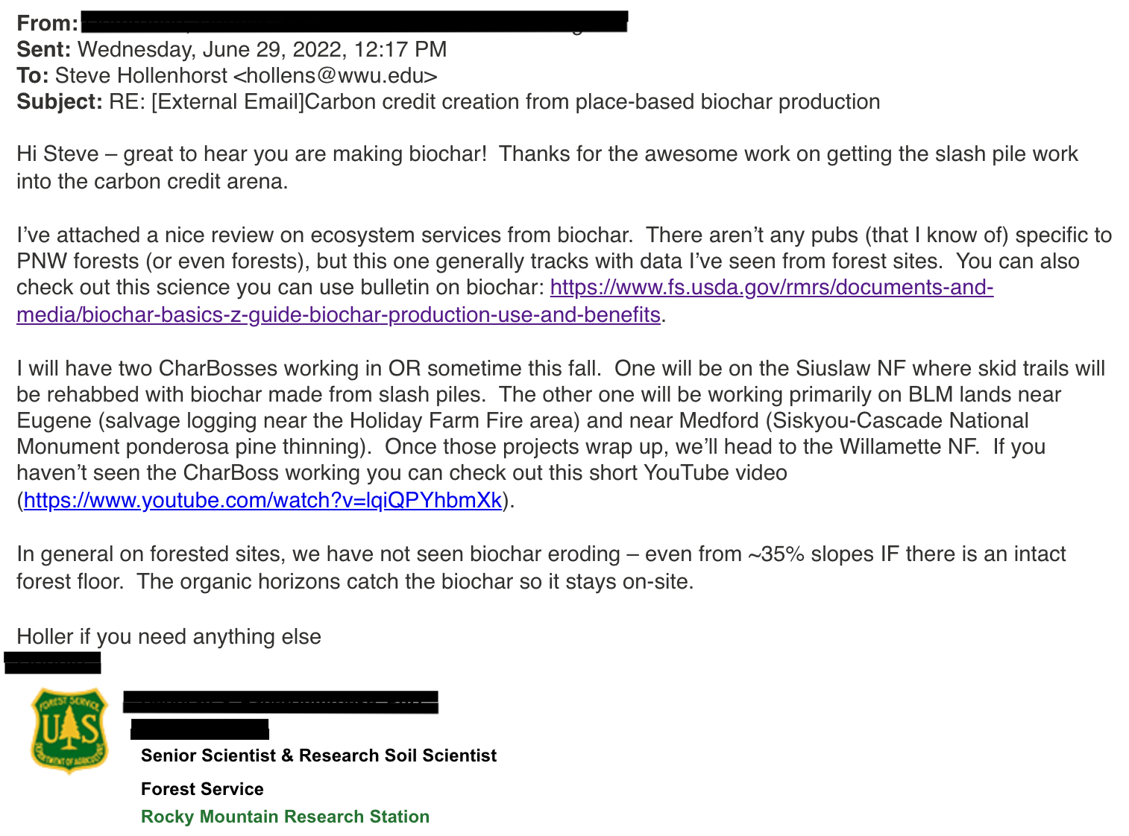

### Exhibit B. Site Pictures.

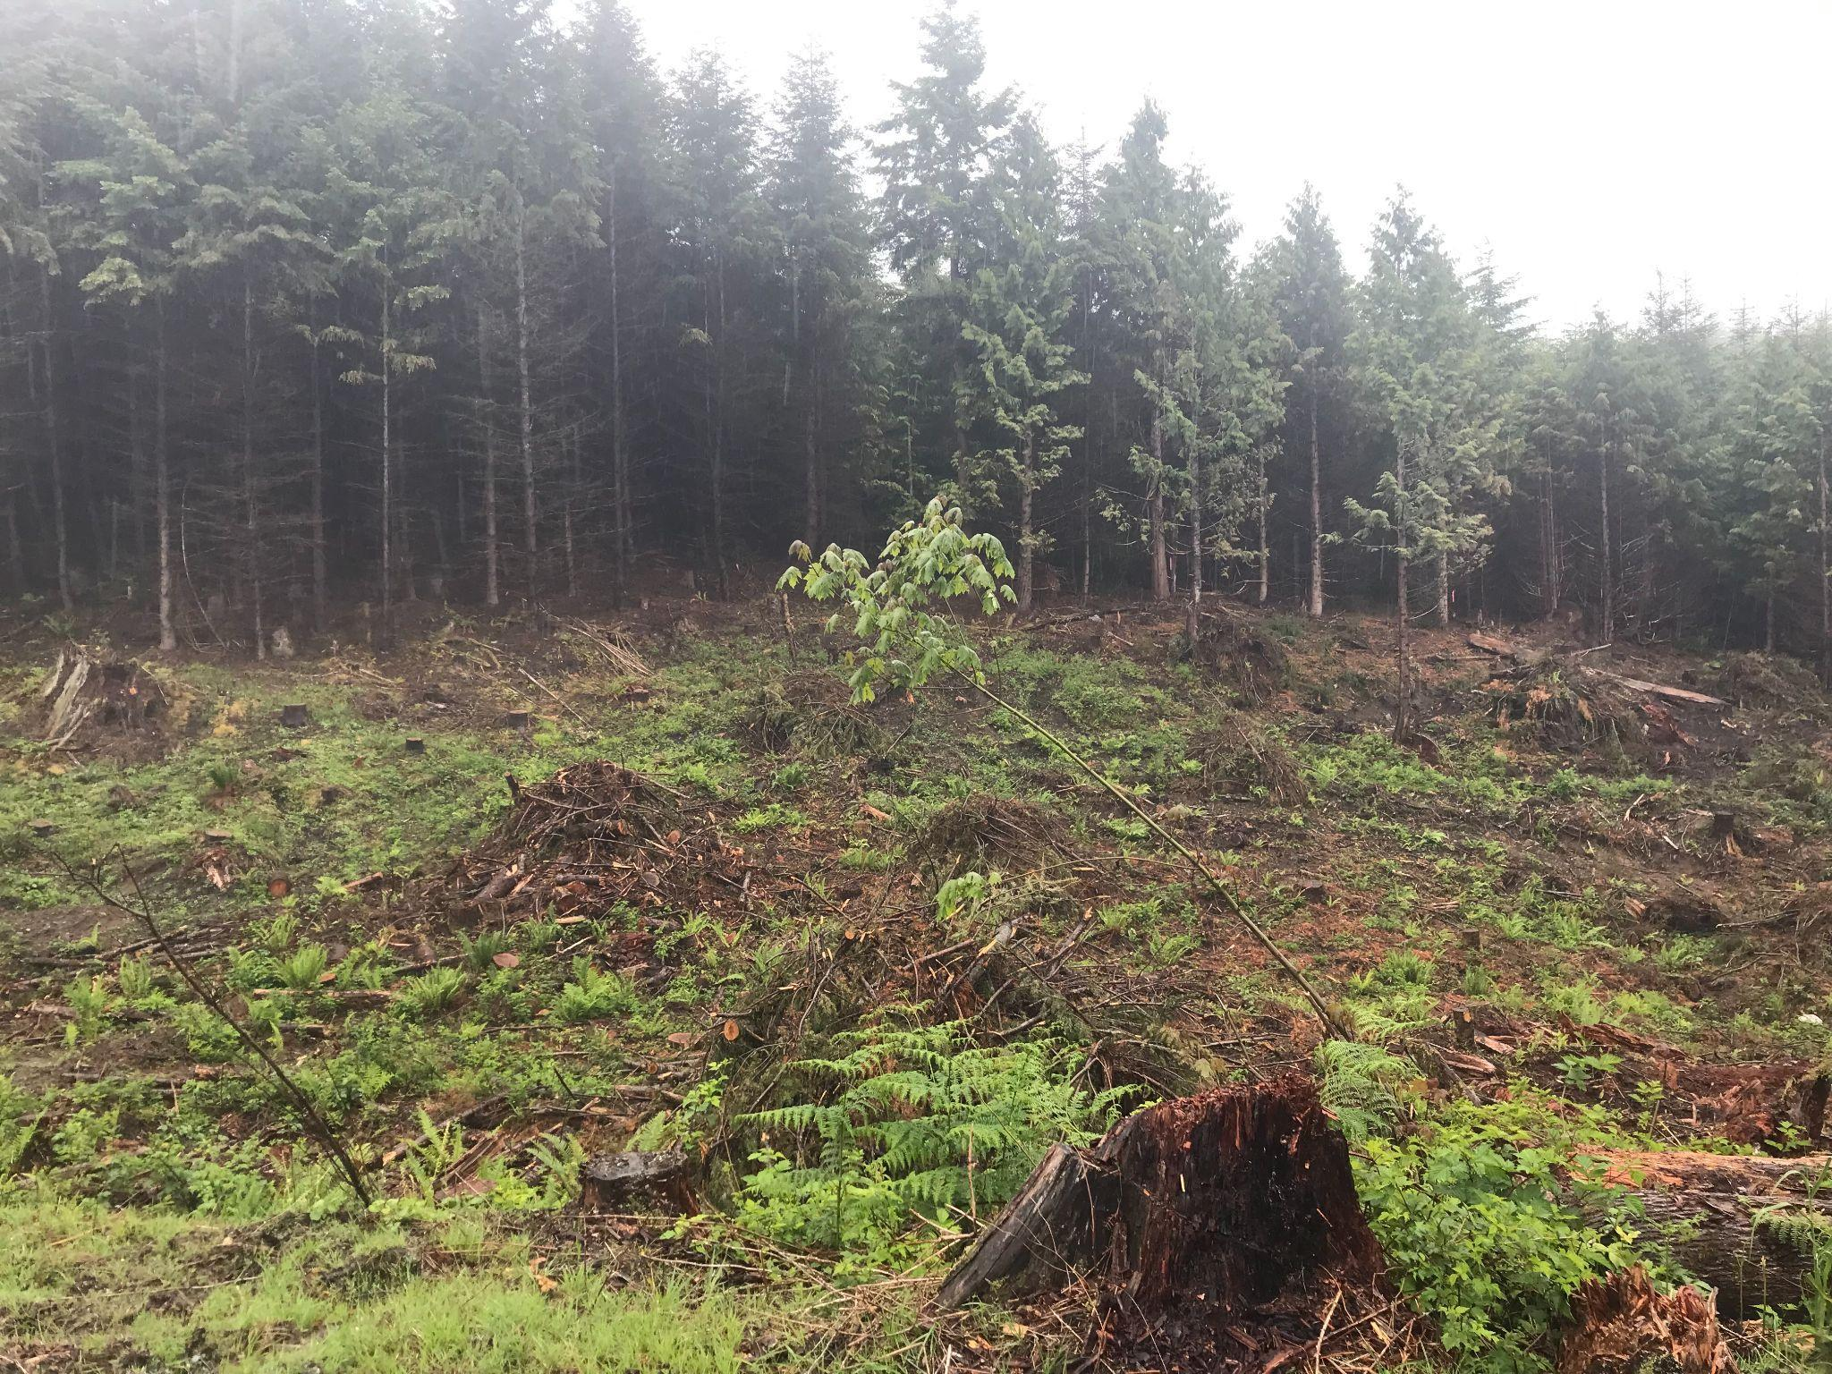

Figure 1. Biochar Pilot Project forest site location. Note the relatively small piles that are distributed throughout the project area. Also note the proximity to intact stands and the presence of foliage and other organic anchors to prevent biochar loss due to water. (Photo credit: Sarah Parker, Kulshan Carbon Trust).

1. See [Link to Methodology](https://verra.org/methodology/methodology-for-biochar-utilization-in-soil-and-non-soil-applications/).
2. The provision that “biochar must be mixed with other substrates” appears to restrict surface application of biochar to instances where compost or manure are available. However, the examples of compost and manure reveal that the methodology is intended to limit biochar surface application only in an agricultural setting. As explained below, in the case of forest applications, we believe that Section 4 does not intend to limit direct use of biochar to the forest floor. In a woodland setting, the forest floor itself functions as a substrate within the meaning of Section 4.
3. See Exhibit A.1 for email correspondence with Verra representatives highlighting this reasoning.
4. Major, J. (2010). Guidelines on Practical Aspects of Biochar Application to Field Soil in Various Soil Management Systems. 23.
5. Amonette et al., 2021. *Biomass to Biochar: Maximizing the Carbon Value.* (53-54). Report by Center for Sustaining Agriculture and Natural Resources, Washington State University, Pullman WA
6. Rumpel et al. (2006). Preferential erosion of black carbon on steep slopes with slash and burn agriculture. *CATENA*, *65*(1), 30–40. <https://doi.org/10.1016/j.catena.2005.09.005>
7. See Exhibit A.2.
8. Major, J. (2010). Guidelines on Practical Aspects of Biochar Application to Field Soil in Various Soil Management Systems. 23.
9. Husk, Barry. (2009). Preliminary Evaluation of Biochar in a Commercial Farming Operation in Canada. Blue Leaf Incorporated: Biochar Field Trial.
10. Page-Dumroese et al., (2016). Opportunities and Uses of Biochar on Forest Sites in North America. In V. J. Bruckman, E. Apaydın Varol, B. B. Uzun, & J. Liu (Eds.), *Biochar* (1st ed., pp. 315–335). Cambridge University Press. <https://doi.org/10.1017/9781316337974.016>
11. Neukirch, Alexis (2022). Biochar Basics: An A to Z Guide to Production, Use, and Benefits. *Science You Can Use Bulletin* (54). Rocky Mountain Research Station, United States Department of Agriculture.
12. Wilson, K. (2022, January 27). Biochar in the Woods [Webinar]. Wilson Biochar. <https://wilsonbiochar.com/resources>
13. WIlson, Biochar in the Woods, 5:58.
14. Hoffman-Krull, K. (2018). Biochar Production for Forestry, Farms, and Communities. *Northwest Natural Resource Group.*
15. Amonette, *Biomass to Biochar,* 62-63.
16. Amonette, *Biomass to Biochar.* 
17. Hoffman-Krull, *Biochar Production.*
18. Neukirch, *Biochar Basics*.
19. Wilson, *Biochar in the Woods.* 
20. Amonette, *Biomass to Biochar, p.xiii.* 
21. Pecha et al. (2022). Basics of biochar production and co-products. Chapter 8.
22. ​​Lehmann, J. (2007). Bio-energy in the black. *Frontiers in Ecology and the Environment*, *5*(7), 381–387. https://doi.org/10.1890/1540-9295(2007)5[381:BITB]2.0.CO;2.
23. McElligott, K. (2011). Biochar Amendments to Forest Soils Effects on Soil Properties and Tree Growth. [Unpublished Master’s Thesis]. *College of Graduate Studies, University of Idaho*
24. Gao, S., Hoffman-Krull, K., Bidwell, A. L., & DeLuca, T. H. (2016). Locally produced wood biochar increases nutrient retention and availability in agricultural soils of the San Juan Islands, USA. *Agriculture, Ecosystems & Environment*, *233*, 43–54. <https://doi.org/10.1016/j.agee.2016.08.028>
25. Gergel et al., 2020. Conceptual Links between Landscape Diversity and Diet Diversity: A Roadmap for Transdisciplinary Research. *BioScience*, *70*(7), 563–575. https://doi.org/10.1093/biosci/biaa048
26. Wind and water parameters adapted from a conservation burn plan developed by the Island County Conservation District Project Manager. “Orcas Fire and Rescue Burn Permit Appendix: Conservation Burn Methodology”. Our project is similar in scale and ecosystem.
27. Page-Dumroese, D. S., Jurgensen, M. and Terry, T. (2010). Maintaining soil productivity during forest biomass-to-energy thinning harvests in the western United States. Western Journal of Applied Forestry, 25, pp. 5–11.
28. Neukirch, *Biochar Basics,* 1*.* 
29. Amonette, *Biomass to Biochar.*
30. Hoffman-Krull, *Biochar Production.*
31. Neukirch, *Biochar Basics*.
32. Wilson, *Biochar in the Woods.* 
33. Gough, C. (2011). *Terrestrial Primary Production: Fuel for Life | Learn Science at Scitable*. https://www.nature.com/scitable/knowledge/library/terrestrial-primary-production-fuel-for-life-17567411/
34. Pan et al. (2011). A Large and Persistent Carbon Sink in the World’s Forests. *Science*, *333*(6045), 988–993. <https://doi.org/10.1126/science.1201609>
35. Amonette, *Biomass to Biochar.*
36. Atkinson, C. J., Fitzgerald, J. D. and Hipps, N. A. (2010). Potential mechanisms for achieving agricultural benefits from biochar application to temperate soils: a review. Plant and Soil, 337, pp. 1–18.
37. Van Zwieten, L. V., Singh, B. P. and Cox, J. (2012). Biochar effects on soil properties. In: Cox, J. (ed.) Biochar in Horticulture: Prospects for the Use of Biochar in Australian Horticulture. New South Wales, Australia: Horticulture Australia, NSW Department of Primary Industries, Chapter 4.
38. Amonette, *Biomass to Biochar,* 53-54*.* 
39. Sarauer, J. L., Page-Dumroese, D. S., & Coleman, M. D. (2019). Soil greenhouse gas, carbon content, and tree growth response to biochar amendment in western United States forests. *GCB Bioenergy*, *11*(5), 660–671. https://doi.org/10.1111/gcbb.12595
40. Amonette, *Biomass to Biochar,* 8.
41. Borchard et al. (2019). Biochar, soil and land-use interactions that reduce nitrate leaching and N2O emissions: A meta-analysis. *Science of The Total Environment*, *651*, 2354–2364. <https://doi.org/10.1016/j.scitotenv.2018.10.060>
42. Jindo et al. (2020). Role of biochar in promoting circular economy in the agriculture sector. Part 1: A review of the biochar roles in soil N, P and K cycles. *Chemical and Biological Technologies in Agriculture*, *7*(1), 15. <https://doi.org/10.1186/s40538-020-00182-8>
43. Gujre et al. (2021). Sustainable improvement of soil health utilizing biochar and arbuscular mycorrhizal fungi: A review. *Environmental Pollution*, *268*, 115549. <https://doi.org/10.1016/j.envpol.2020.115549>
44. Li et al. (2018). Effects of biochar application in forest ecosystems on soil properties and greenhouse gas emissions: A review. *Journal of Soils and Sediments*, *18*(2), 546–563. <https://doi.org/10.1007/s11368-017-1906-y>
45. Bauhus, J., & Khanna, P. K. (1999). The significance of microbial biomass in forest soils. *Going underground-ecological studies in forest soils. Trivandrum, India: Research Signpost*, 77-110.
46. Ameloot et al. (2013). Interactions between biochar stability and soil organisms: review and research needs. *European Journal of Soil Science*, 64, 379– 390.
47. Gul et al. (2015). Physico-chemical properties and microbial responses in biochar-amended soils: Mechanisms and future directions. *Agriculture, Ecosystems & Environment*, 206, 46– 59.
48. Lehmann et al. (2011). Biochar effects on soil biota – A review. *Soil Biology and Biochemistry*, 43, 1812– 1836.
49. Sarauer, *Soil Greenhouse Gas.* 
50. McElligott, Biochar Amendments.
51. Sarauer, *Soil Greenhouse Gas.* 
52. Thomas, S. C., & Gale, N. (2015). Biochar and forest restoration: A review and meta-analysis of tree growth responses. *New Forests*, *46*(5), 931–946. <https://doi.org/10.1007/s11056-015-9491-7>
53. Palviainen et al. (2020). Biochar amendment increases tree growth in nutrient-poor, young Scots pine stands in Finland. *Forest Ecology and Management*, *474*, 118362. https://doi.org/10.1016/j.foreco.2020.118362
54. Wilson, K. (2016). Biochar for Forest Restoration in the Western United States. Wilson Biochar Associates.
55. Sarauer, *Soil Greenhouse Gas.* 
56. Amonette, *Biomass to Biochar,* 63.
57. Neukirch, *Biochar Basics*.
58. Wilson, Forest Restoration.
59. DeLuca, T. H., & Aplet, G. H. (2008). Charcoal and carbon storage in forest soils of the Rocky Mountain West. *Frontiers in Ecology and the Environment*, *6*(1), 18–24. <https://doi.org/10.1890/070070>
60. Amonette, *Biomass to Biochar,* 59.
61. Wilson, *Biochar in the Woods, 5:58.* 
62. Amonette, *Biomass to Biochar,* 73.
63. Jien, S.-H., & Wang, C.-S. (2013). Effects of biochar on soil properties and erosion potential in a highly weathered soil. *CATENA*, *110*, 225–233. https://doi.org/10.1016/j.catena.2013.06.021
64. Amonette, *Biomass to Biochar,* 73.